Name : Mayur Ravikant Patil

Practical No.1

Roll No.34 Batch: T2

1. **Aquire**

//Reads the contents of a file and creates a String array of its individual lines.

//If the name of the file is used as the parameter, as in the above example,

//the file must be loaded in the sketch's "data" directory/folder.

//loadStrings(filename)

**String[] lines;**

**void setup() {**

**size(400, 400);**

**lines = loadStrings("list.txt");**

**println("There are " + lines.length + " lines");**

**}**

**void draw() {**

**background(220); // Clear the background**

**// Display the lines on the canvas with black text color**

**textSize(16);**

**textAlign(LEFT);**

**fill(0); // Set text color to black**

**for (int i = 0; i < lines.length; i++) {**

**text(lines[i], 20, 40 + i * 20); // Adjust position as needed**

**}**

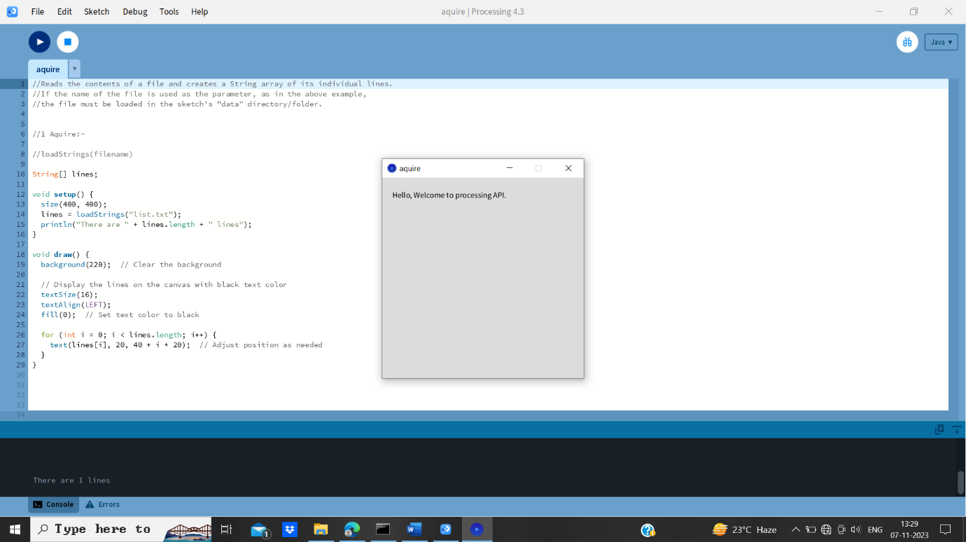**}**

1. Parse

// split()

**String men = "Chernenko,Andropov,Brezhnev";**

**String[] list = split(men, ',');**

**void setup() {**

**for (int i = 0; i < list.length; i++) {**

**println("list[" + i + "] is now " + list[i]);**

**}**

**}**

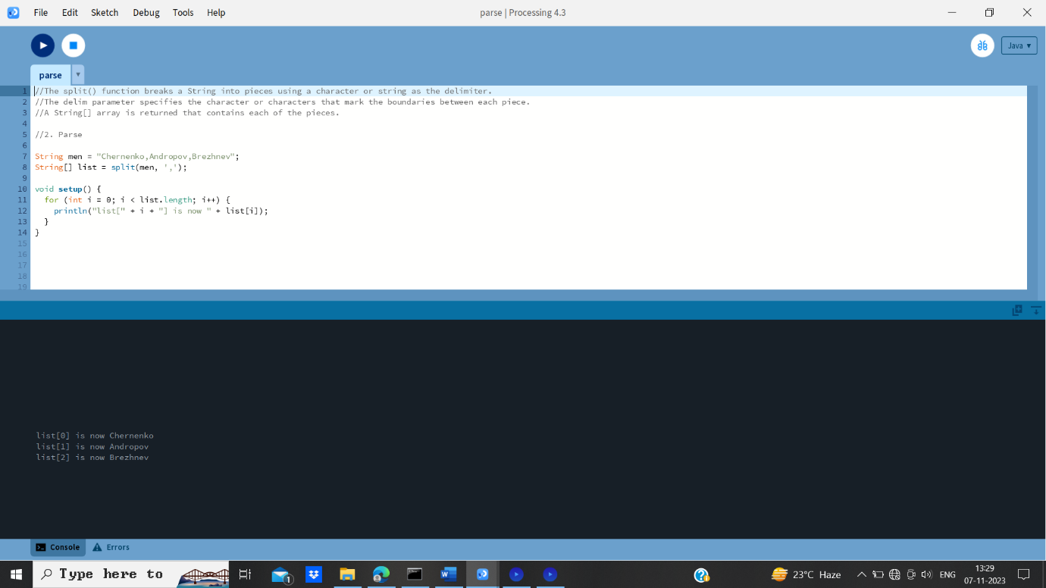

1. **Filter**

**size(400, 400);**

**for (int i = 0; i < 160; i = i+1)**

**{**

**line(120, i, 320, i);**

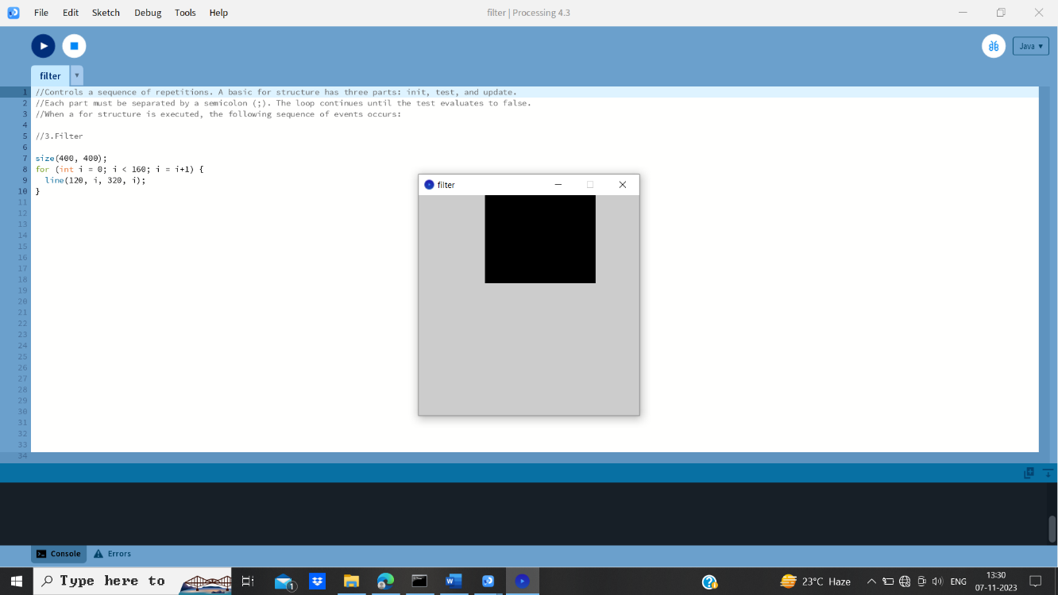**}**

1. **Mine**

// max():-

**int a, b;**

**float c;**

**void setup() {**

**size(400, 200);**

**a = max(5, 9);**

**b = max(-4, -12);**

**c = max(12.3, 230.24);**

**}**

**void draw() {**

**background(220);**

**textSize(20);**

**textAlign(CENTER);**

**fill(0);**

**text( a, width/4, height/2 );**

**text( b, width/2, height/2 );**

**text( c, 3 * width/4, height/2);**

**}**

1. 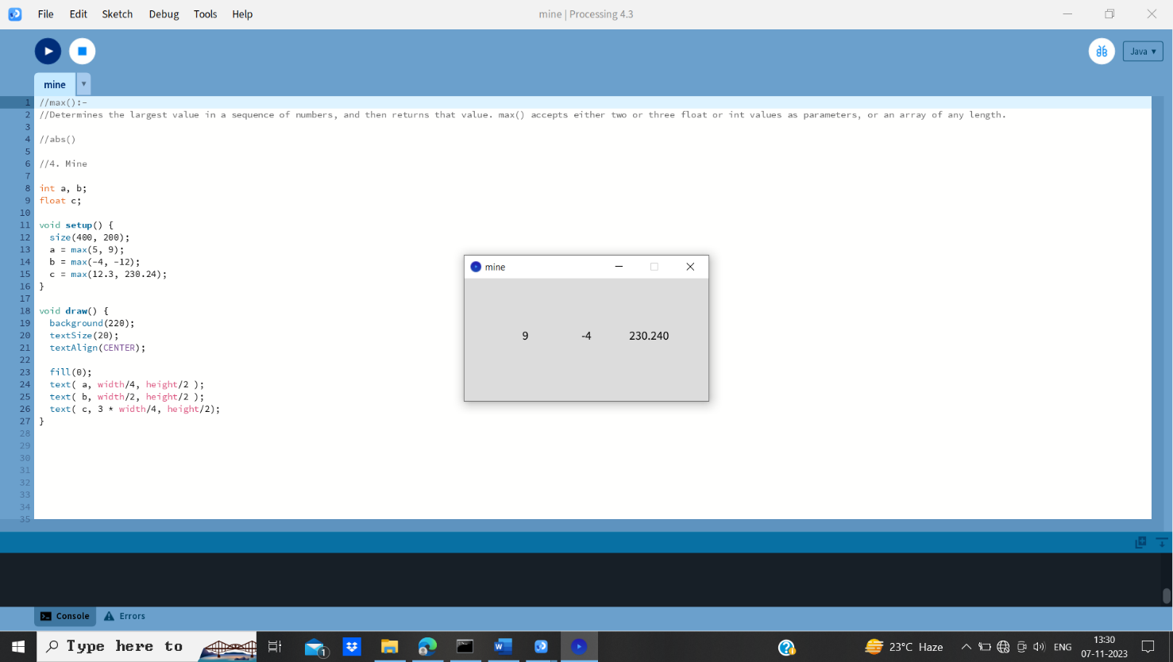**Represent**

//map():-

**void setup() {**

**size(400, 400);**

**noStroke();**

**}**

**void draw() {**

**background(204);**

**float x1 = map(mouseX, 0, width, 100, 150);**

**ellipse(x1, 75, 50, 50);**

**float x2 = map(mouseX, 0, width, 0, 200);**

**ellipse(x2, 125, 50, 50);**

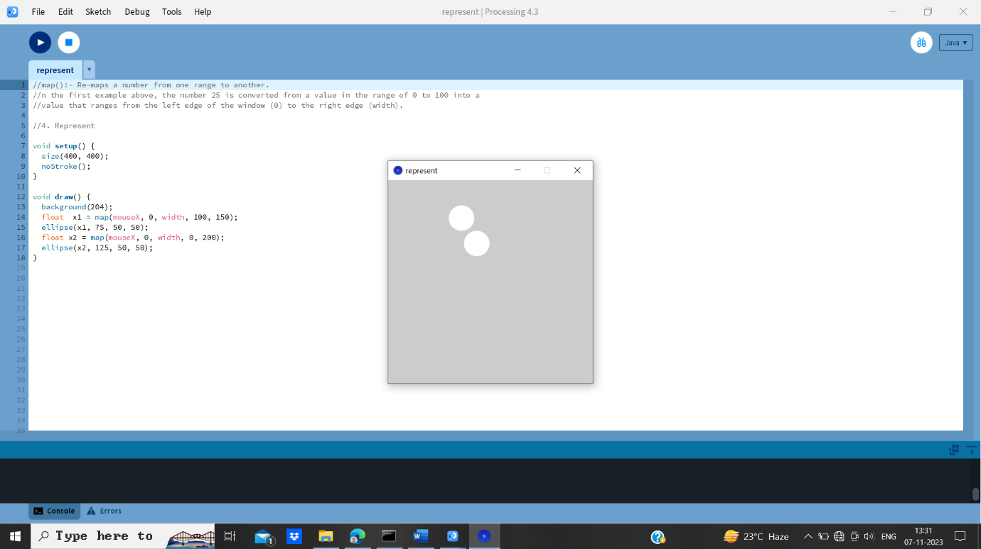**}**

1. **Refine**

//stokeweight

**void setup() {**

**size(400, 400);**

**}**

**void draw() {**

**background(220);**

**stroke(0); // Set stroke color to black**

**strokeWeight(4); // Default**

**line(80, 80, 320, 80);**

**strokeWeight(16); // Thicker**

**line(80, 160, 320, 160);**

**strokeWeight(40); // Beastly**

**line(80, 280, 320, 280);**

**}**

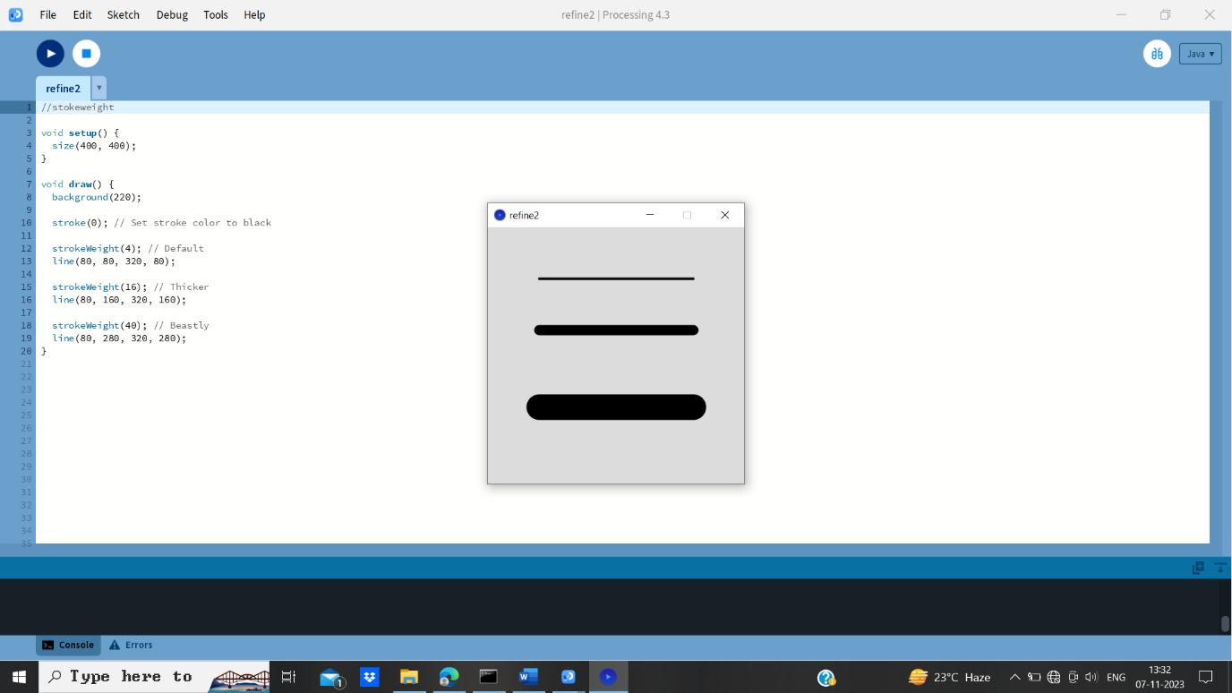

1. **Interact**

//mouseDragged()

**// Drag (click and hold) your mouse across the**

**// image to change the value of the rectangle**

**int value = 0;**

**void setup()**

**{**

**size(400,400);**

**}**

**void draw() {**

**fill(value);**

**rect(100,100, 150, 150);**

**}**

**void mouseDragged()**

**{**

**value = value + 5;**

**if (value > 255) {**

**value = 0;**

**}**

**}**

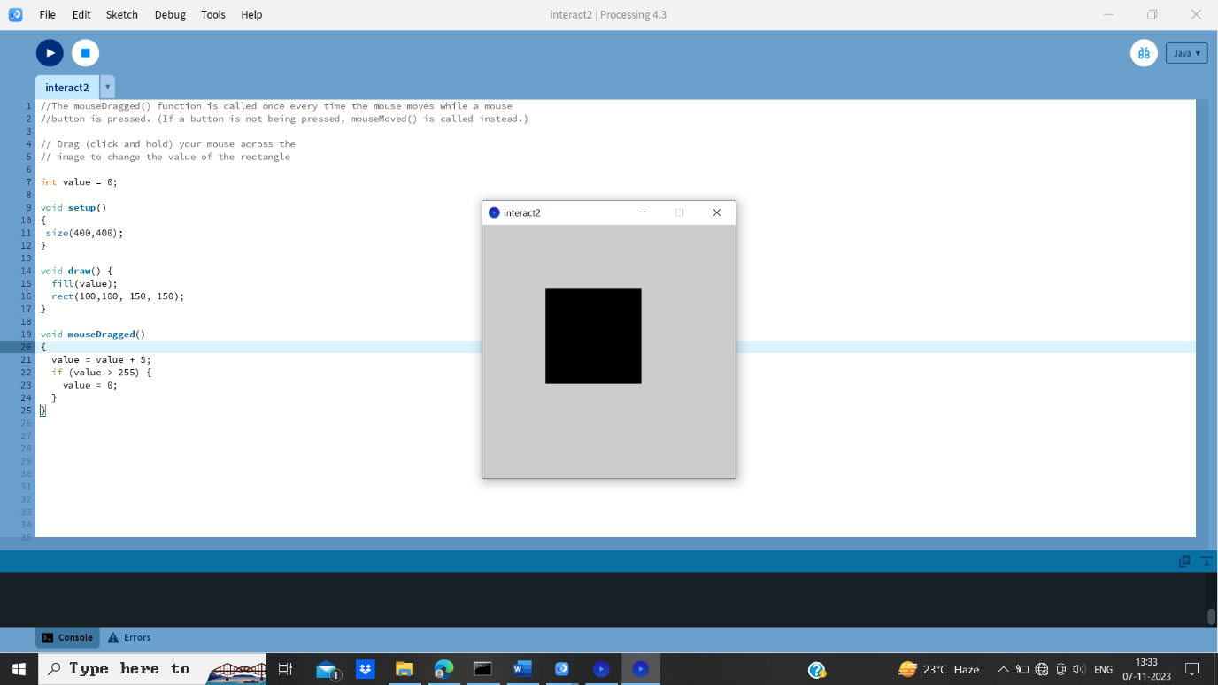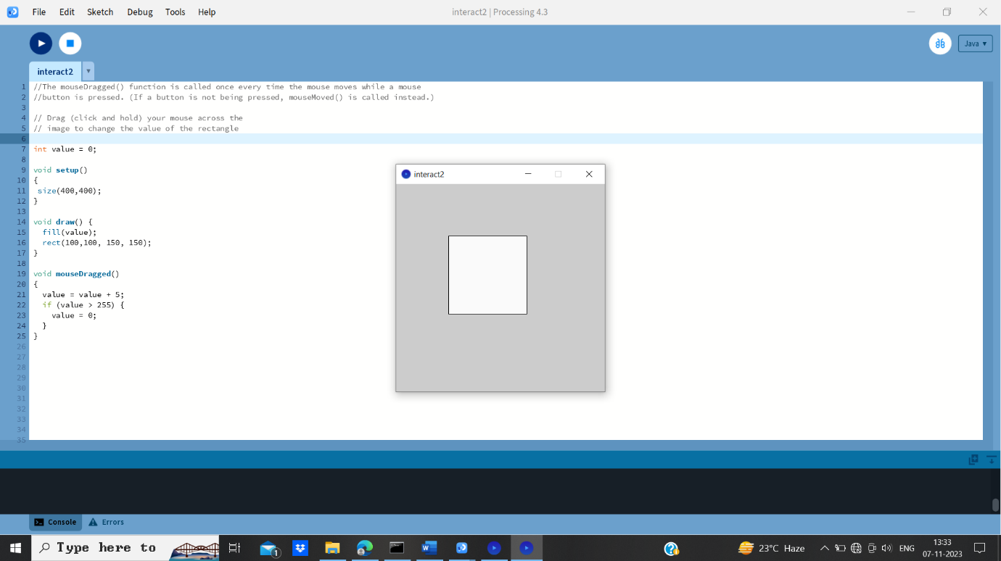 **Before After mousedrag**

**Drawing Map with locations**

**PImage mapImage;**

**Table locationTable;**

**int rowCount;**

**void setup()**

**{**

**size(900, 700);**

**mapImage = loadImage("map.png");**

// Make a data table from a file that contains

// the coordinates of each state.

**locationTable = new Table("locations.tsv");**

// The row count will be used a lot, so store it globally.

**rowCount = locationTable.getRowCount( );**

**}**

**void draw( ) {**

**background(255);**

**image(mapImage, 0, 0);**

// Drawing attributes for the ellipses.

// smooth( );

**fill(192, 0, 0);**

**noStroke( );**

// Loop through the rows of the locations file and draw the points.

**for (int row = 0; row < rowCount; row++) {**

**float x = locationTable.getFloat(row, 1); // column 1**

**float y = locationTable.getFloat(row, 2); // column 2**

**ellipse(x, y, 4, 4);**

**}**

